**Database Management - Assignment: Database System**

**Christian Oxner**

**Study.com**

PROMPT #1:



PROMPT #2:

To Create the first table users. Could not figure out how to set zip(5) so tried to do it with a check statement. Thought of going another route and using a decimal instead. Zip(5) would not work. Also had to assign values to varchar or else it would be set to 1 by default so went with 255 as it seems to be the standard.

** Note took screenshots of tables after assignment so some values say not null but it was added in prompt 3 not prior

CREATE TABLE users (

userid INT NOT NULL AUTO_INCREMENT PRIMARY KEY,

name VARCHAR 255),

username VARCHAR 255),

address VARCHAR (255),

city VARCHAR(255),

state VARCHAR(2),

zip INT,

CHECK(CHAR_LENGTH(zip) = 5),

password VARCHAR (255)

);

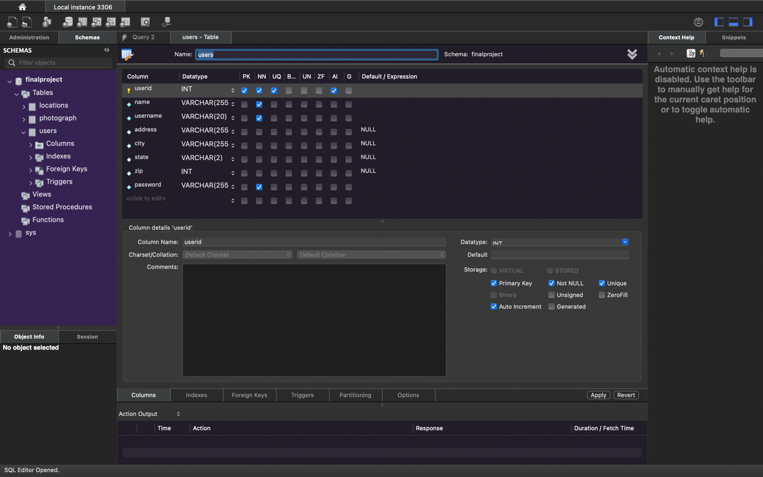

Code to create locations table was not able to add auto increment without adding a primary key to the table.

CREATE TABLE locations (

itemid INT NOT NULL AUTO_INCREMENT PRIMARY KEY,

type INT,

description VARCHAR(255),

lng REAL,

lat REAL

);

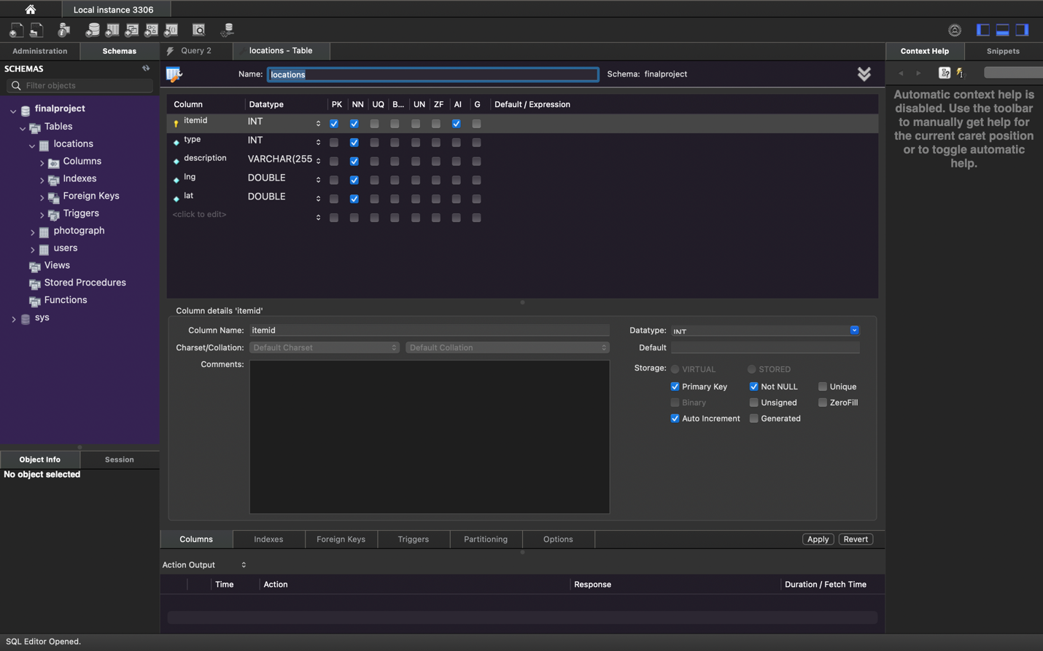

Final photograph table

CREATE TABLE photograph (

photoid INT,

locationid INT

);

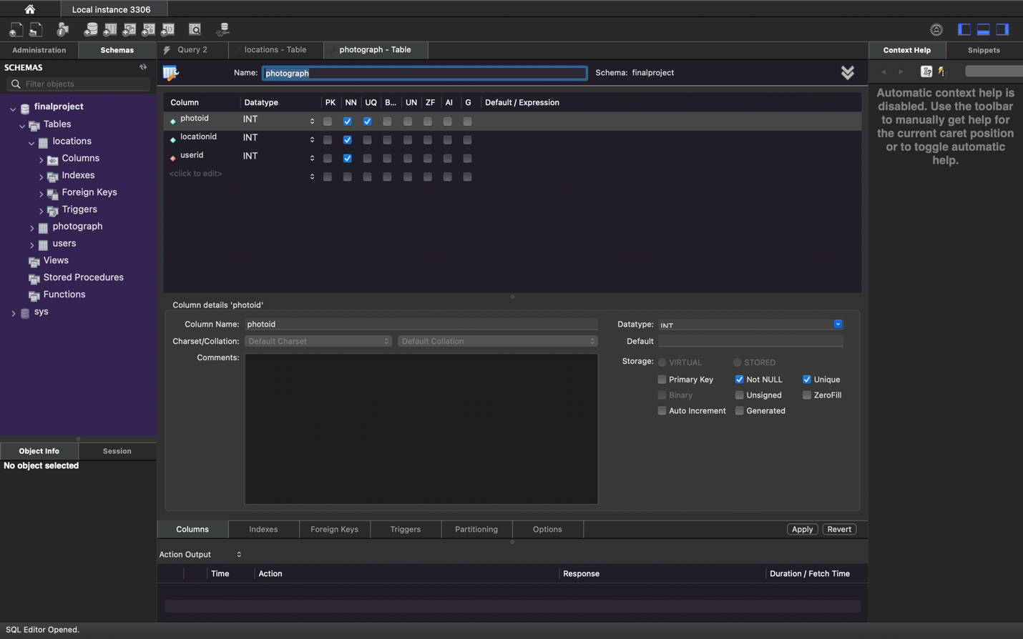

Prompt 3:

Alters all table to make values not nullable

ALTER TABLE locations MODIFY type INT NOT NULL;

ALTER TABLE locations MODIFY description VARCHAR(255) NOT NULL;

ALTER TABLE locations MODIFY lng REAL NOT NULL;

ALTER TABLE locations MODIFY lat REAL NOT NULL;

ALTER TABLE users MODIFY name VARCHAR(255) NOT NULL;

ALTER TABLE users MODIFY username VARCHAR(20) NOT NULL;

ALTER TABLE users MODIFY password VARCHAR(255) NOT NULL;

ALTER TABLE photograph MODIFY photoid INT NOT NULL;

ALTER TABLE photograph MODIFY locationid INT NOT NULL;

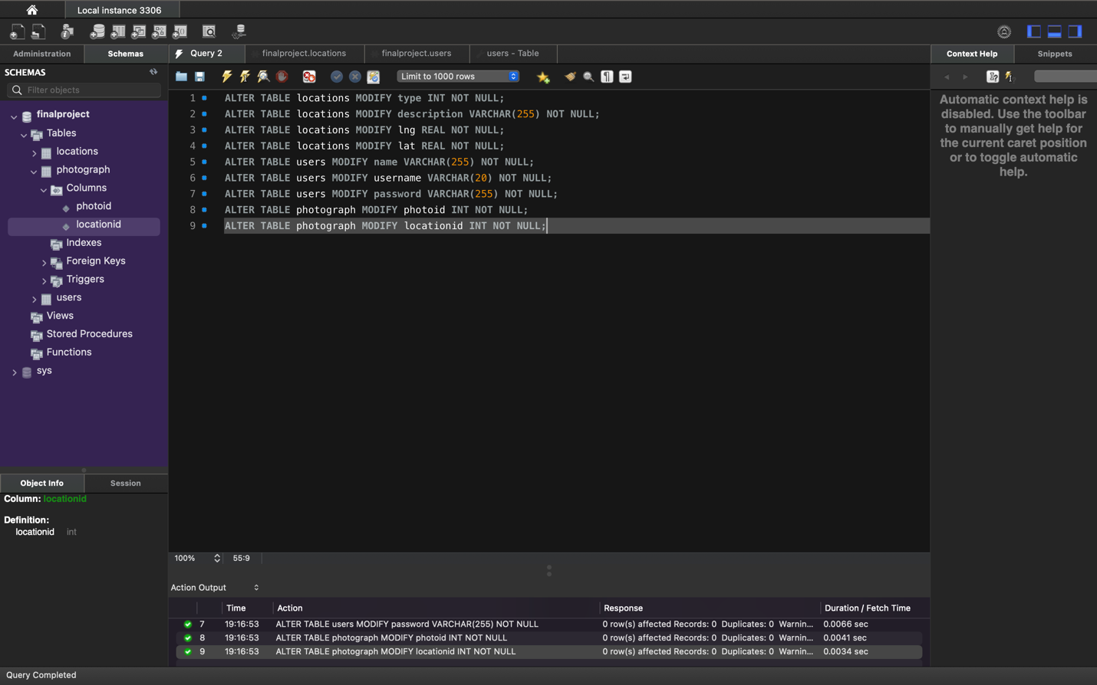

Prompt 4:

CREATE UNIQUE INDEX photographid ON photograph (photoid);

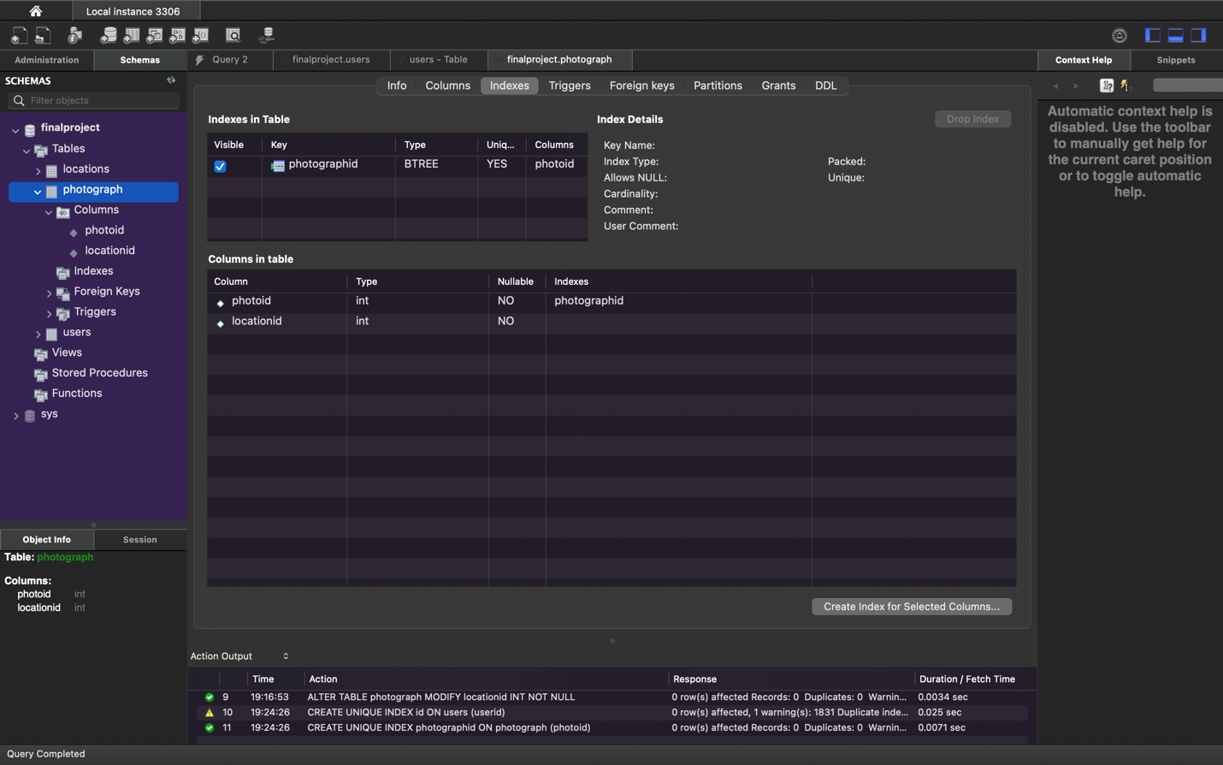

PROMPT 5:

Added new users to the data base for auto increment to work had to decalre the first value as null.

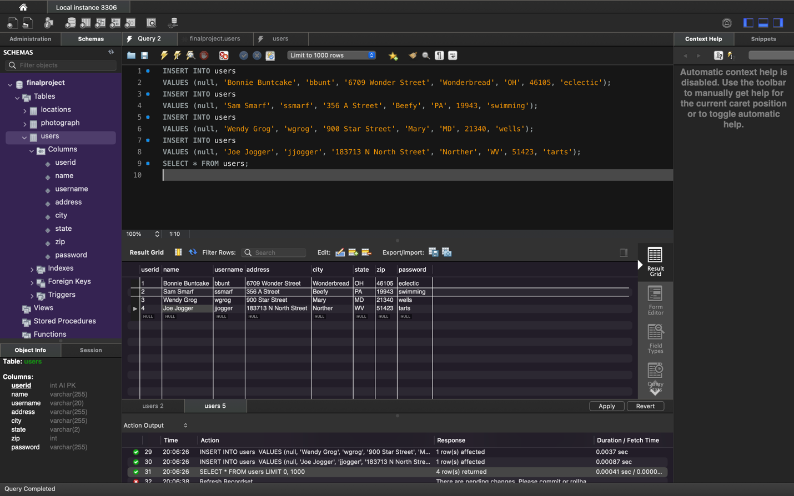

PROMPT 6:



PROMPT 7:

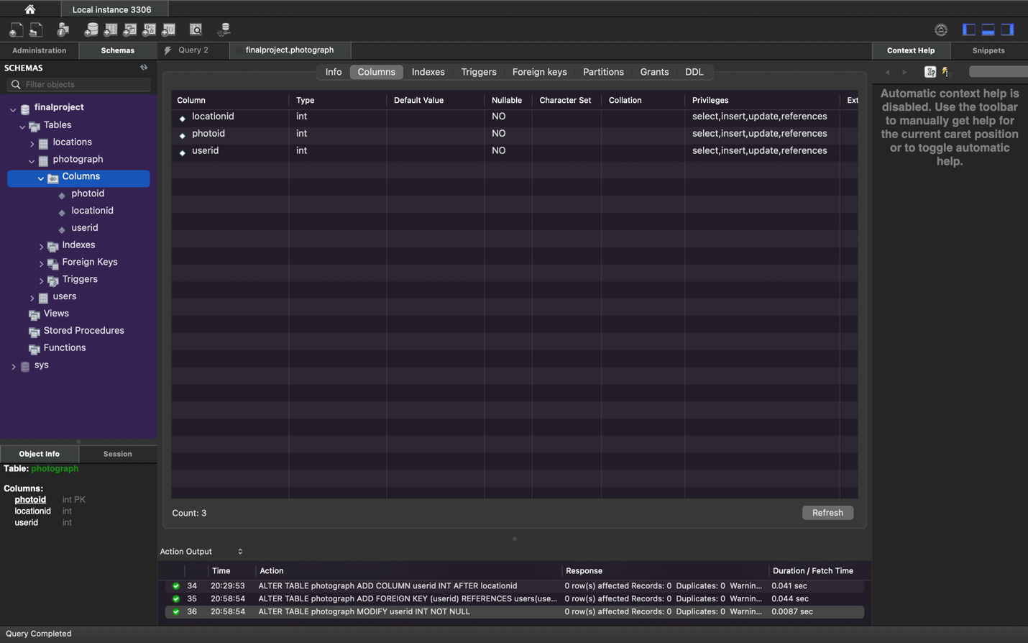

PROMPT:8

There are two issues that arise when we add this column to the photograph tables. The first is what we did earlier by declaring that the variable cannot be null. In the users table the userid column cannot be null to ensure data integrity we have to make sure this is the case in this table to. The second problem is that we need to recognize the relationship existing within the database. Userid is the primary key in another table making it a foreign key in this table, to maintain data integrity we have to recognize this relationship exist.



PROMPT 9:

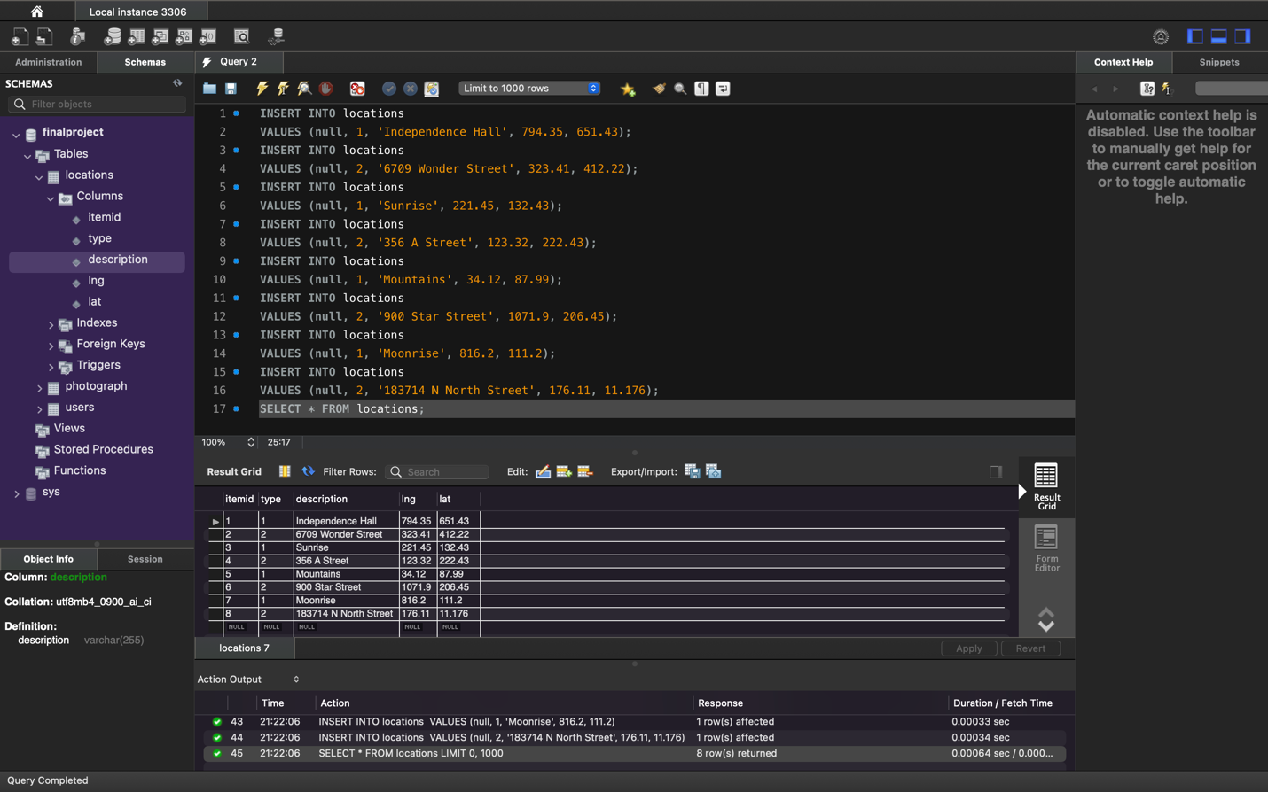

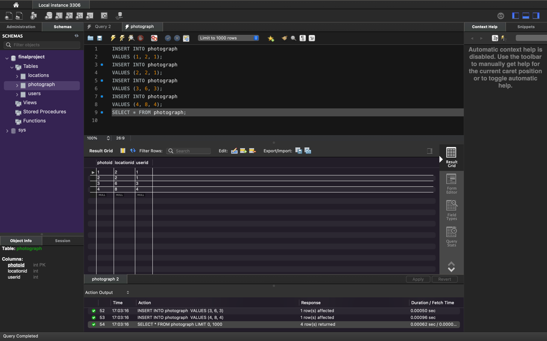

PROMPT #10



PROMPT #11

SELECT name

FROM users, photograph

WHERE users.userid = photograph.userid ;

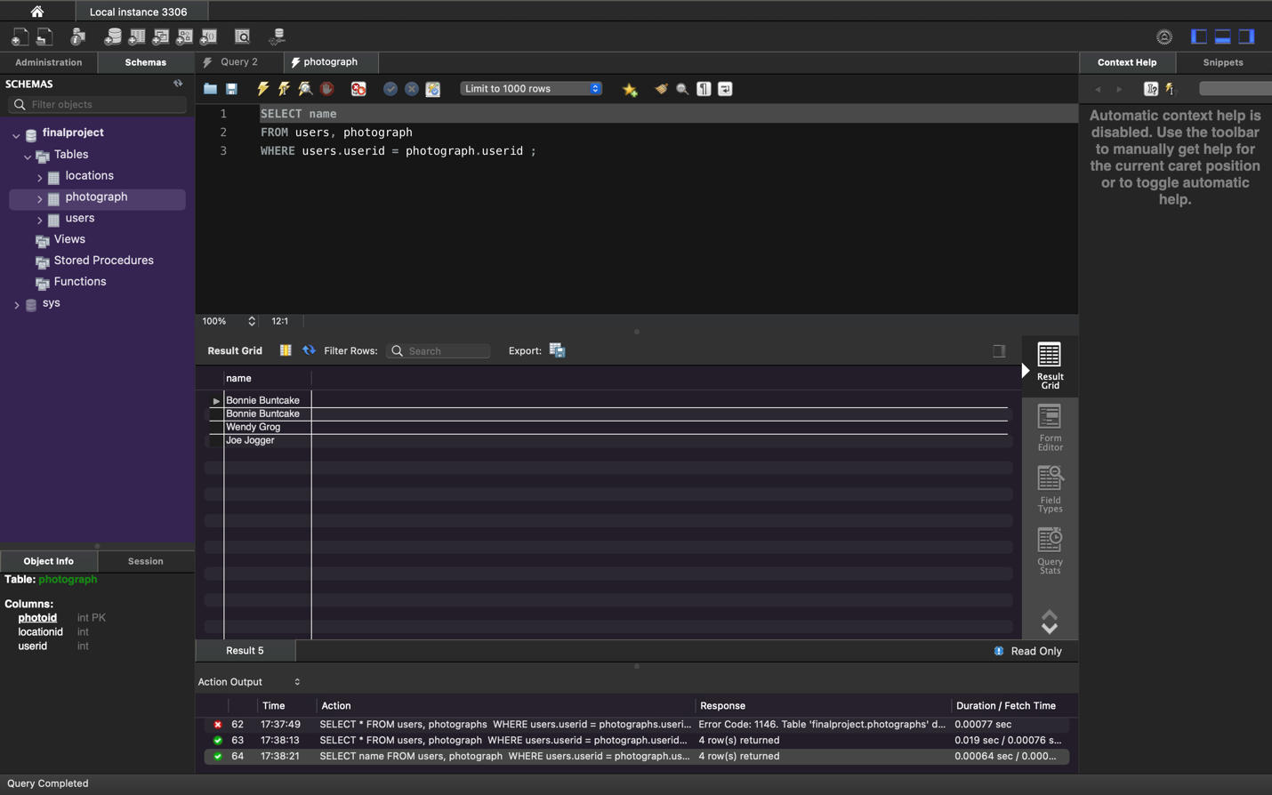

PROMPT #12

SELECT DISTINCT name

FROM users, photograph

WHERE users.userid = photograph.userid ;

